**Design and Development of a Tic-Tac-Toe Game Using Pygame**

**Project Information**

**Group Members:**

* Jarif Ansath Aorko - 2521013
* Bisshwajit Chandra Das - 2520859
* Tousif Siddique - 2521147

**Problem Understanding & Objectives**

We were provided with a basic Tic-Tac-Toe game code using Pygame as our starting point. Our task was to enhance this base code by adding features that would improve the user experience.

The main challenges we identified in the base code were:

* Lack of audio
* Limited customization options
* No score tracking
* Missing game status

Our objectives were to implement four key features:

1. **Sound Effects**  - Add audio feedback on click
2. **Theme Tab with Dropdown Menu** - Provide customization options
3. **Score Tracking and Turns** - Track wins and status of turns
4. **Bottom Status Bar Information** - Display real-time game information

**Implementation of Features**

**1. Sound Effects**

We integrated audio feedback into the base game to make interactions more engaging. Players now can hear sound effects when they click on squares, when someone wins or ends in a draw.

**Technical Implementation:**

* Used pygame.mixer to enable sound functionality in the game.
* Added sound effects for different game events

**2. Theme Tab with Dropdown Menu**

We added a theme selection tab that allows players to customize the game's visual appearance. The dropdown menu provides multiple color schemes and visual styles that players can switch between during gameplay.

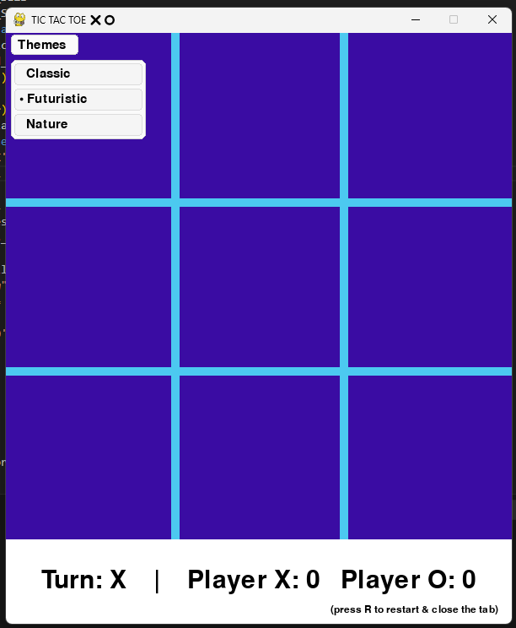

**Technical Implementation:**

* Created a dropdown menu interface using Pygame's drawing functions
* Implemented theme switching logic that updates colors in real-time
* Stored theme configurations in a structured format for easy modification

**3. Score Tracking and Turns**

We enhanced the base game with a scoring system that tracks wins across multiple rounds. The game now clearly shows whose turn it is and maintains a running score.

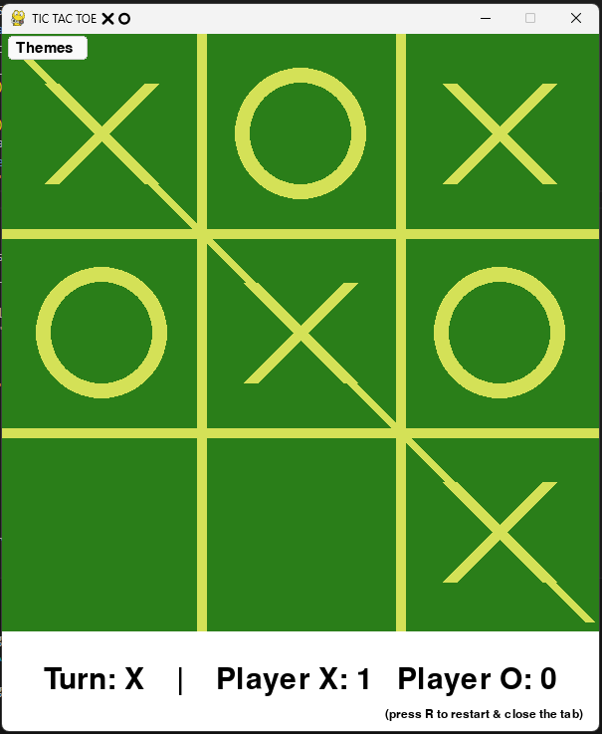

**Technical Implementation:**

* Added score variables and turn tracking logic
* Created visual indicators for current player and score display

**4. Bottom Status Bar Information**

We added an information bar at the bottom of the screen that displays important game details including current game status, player information, and hints.

**Technical Implementation:**

* Designed a status bar layout that doesn't interfere with gameplay
* Implemented dynamic text updates based on game events

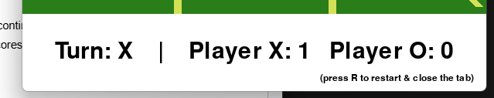

**Challenges Faced to Solve the Problems**

**First of all we neither knew how to add those features**

**Solution:** Our team member sourced some sources to begin with like web blogs and youtube videos

then we studied them



**How Did We Solve the Problems**

**Development Process**

1. **Code Analysis:** We first studied the base code thoroughly to understand its structure and identify where our features could be integrated
2. **Feature Planning:** Each team member researched their assigned features and planned the implementation approach
3. **Incremental Development:** We added one feature at a time, testing thoroughly before moving to the next
4. **Integration Testing:** After implementing all features, we tested them together to ensure its working

**Team Collaboration**

* **Aorko** handled the core development work and testing of all features
* **Bisswajit** designed the user interface elements and documented our progress
* **Tousif** solved technical problems and maintained code documentation

**Problem-Solving Approach**

When we encountered issues, we followed a systematic approach:

1. Identify the exact problem and its scope
2. Research similar issues online and in Pygame documentation
3. Test potential solutions in isolated code before integrating



**Contributions**

**Jarif Ansath Aorko - Developer & Tester**

* Implemented the sound effects using pygame.mixer
* Developed the theme switching functionality
* Integrated all features into the base code
* Conducted comprehensive testing to ensure reliability
* Fixed bugs and optimized performance

**Bisshwajit Chandra Das - Report Writer & Feature Brainstorming**

* Designed the user interface for the theme dropdown menu
* Planned the layout and content of the status bar
* Created this comprehensive project report
* Coordinated feature requirements and user experience design
* Documented the development process

**Tousif Siddique - Problem Solving & Documentation**

* Solved technical challenges related to real-time theme switching
* Developed the score tracking and turn management system
* Created and maintained code documentation
* Researched solutions for performance optimization
* Established coding standards for team collaboration

